

**DIPLOMADO DE ORACLE.**

**Isac Samil Peñalo Montero**  **08/12/2018**

**Matricula: EC20181332**

**Leandro Fondeur**

**Práctica #5- Creando tablas y otros objetos de esquema.**

**Practice 1.10**

1. Create the DEPT table based on the following table instance chart. Confirm that the table is created.

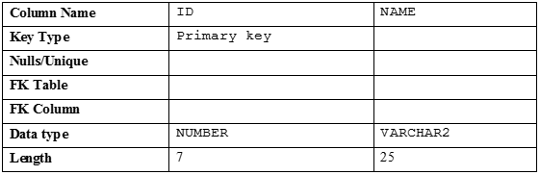

1. Populate the DEPT table with data from the DEPARTMENTS table. Include only columns that you need.
2. Create the EMP table based on the following table instance chart. Confirm that the table is created.

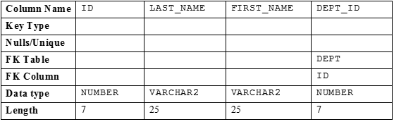

1. Create the EMPLOYEES2 table based on the structure of the EMPLOYEES table. Include only the EMPLOYEE_ID, FIRST_NAME, LAST_NAME, SALARY, and DEPARTMENT_ID columns. Name the columns in your new table ID, FIRST_NAME, LAST_NAME, SALARY, and DEPT_ID, respectively.
2. Alter the EMPLOYEES2 table status to read-only.
3. Try to insert the following row in the EMPLOYEES2 table:



You get the following error message:

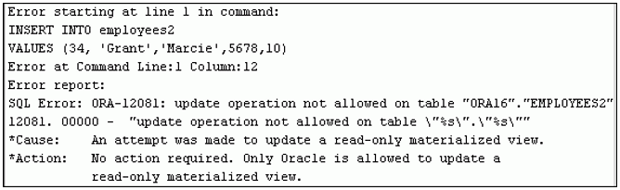

1. Revert the EMPLOYEES2 table to the read/write status. Now, try to insert the same row again. You should get the following messages:



1. Drop the EMPLOYEES2 table.